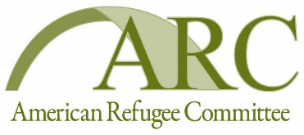

TENDER NOTICE

The American Refugee Committee (ARC) is an international humanitarian agency working with refugees, displaced people, and those at risk to help them survive crises and rebuild lives of dignity, health, security and self-sufficiency. ARC programs in Africa and Asia provide health care, clean water, shelter repair, legal aid, trauma counseling, microcredit, community development services, and repatriation assistance to two million people, annually. ARC bases its relationship with uprooted peoples on mutual respect and a compassionate exchange of knowledge and values.

ARC is seeking for potential suppliers with proven experience for the following projects:

- Install foot operated hand washing facility in South DARFUR.

Tender packages can be picked up at: ARC office in Nyala Hay El-cinema Building #1/1, Plot# 5D, Nyala, Meeting Avenue.
Or in Khartoum ARC office Arkwit Block 57, House 19 Alsalam street
:
Or by submitting a request to the following e-mail address: sudantenders@arcrelief.org

The deadline for submission is 3rd December 2020 at 15:00

Only tenders submitted in prescribed form and deadlines will be considered. Only legally registered firms will be considered.
The Tender package should be submitted in a sealed envelope and clearly marked:
ARC-SUD-2020/ 1376

